**ANALYSIS OF ENERGY EFFICIENT PARAMETERS FOR CLUSTERING SCHEME IN WIRELESS SENSOR NETWORKS**

M.JAYA PRIYA# 1 , K.LOGANAYAKI# 2 , S.PRABA# 3 , M.RAKSHANA# 4 , Dr.J.GNANAMBIGAI, PROFESSOR / ECE

DEPARTMENT OF ELECTRONICS AND COMMUNICATION ENGINEERING

K.S.R. COLLEGE OF ENGINEERING – TIRUCHENGODE

**ABSTRACT**

Wireless sensor networks are remote networks and works in adhoc manner. Sensor collects the information sensed by the self and sends it to cluster head created in clusters. Further cluster heads use to send this information to the sink where data fetched use to complied and processed. In this paper, we will propose a novel method for establishing reliable and efficient data transmission in the wireless sensor networks. Network lifetime is increased by using this technique. To increase reliability and to utilize energy much more effectively multiple mobile sinks are used along with base station. Mobile sink nodes are used to enhance the performance metrics. Mobile sinks will be bring into grid area so that less energy consumption will be there for cluster heads. Mobile sinks will fetch data from cluster heads with minimize energy consumption.

**Keywords:**  Wireless sensor networks, cluster, head selection protocol, multi-hop communication

**I INTRODUCTION**

The recent technological advancements in the field of micro electrical mechanical systems (MEMS) have made the manufacturing and use of small, low

**IJIREEICE**

powered and moderate cost microsensors[1] both technically and economically feasible. A Wireless Sensor Network (WSN) [2] Consists of hundreds to thousands of low-power multi-functioning sensor nodes are operating in an unattended environment, having capabilities of their sensing, computation and communications.

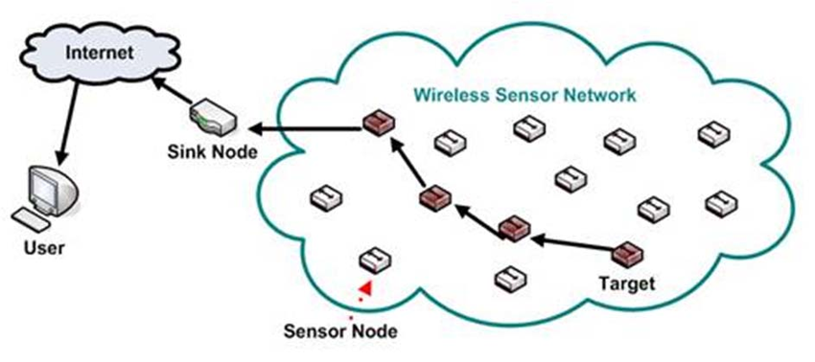

Fig. 1. Wireless Sensor Network [4]

Wireless Sensor Networks are used for monitoring and collecting information from an unattended environment and for reporting events to the user. They monitor physical or environmental conditions such as temperature, humidity, pressure, sound, vibration etc. Since a sensor node is limited in terms of sensing and computation capacities communication performance and power - a large number of sensor nodes can be distributed over an area of interest for collecting information. [3]The decrease in size and cost of the sensor nodes has made it possible to have a network of large number of sensor nodes, thereby increasing the reliability and accuracy of data as well as the area of coverage. Due to the low-cost deployment, the nodes are generally deployed with greater degree of connectivity. Such redundancy also increases the network fault tolerance as the failure of a single node has negligible impact on the entire network operation. [4] LEACH assumes a simple model for the radio hardware energy to run the radio electronics and the power amplifier, and the receiver dissipates energy to run the radio electronics. For the experiments described here, both the free space and the multipath fading channel models were used, depending on the distance between the transmitter and receiver [6].

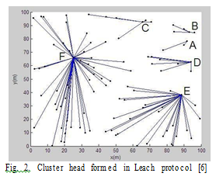

**II RELATED WORK**

Smart sensors and network topology are prerequisites to achieve the maximum network lifetime. Here, an accurate routing should be used to not lose any data packet. In this section, several types of routing protocols are explained. There are two types of routing protocols; flat and hierarchal. Flat protocols distribute routing information to routers that are connected to each other without any organization or segmentation structure between them, while hierarchal protocols often group nodes together by a function into a hierarchy.

The low-energy adaptive clustering hierarchy (LEACH) and another improved centralized LEACH deploy randomized rotation of cluster-heads to evenly distribute the energy load among all sensors in a WSN. This paper proposes an improved LEACH (LEACH-C) algorithm called partition-based LEACH (pLEACH), which firstly partitions the network into optimal number of sectors, and then selects the node with the highest energy as the head for each sector, using the centralized calculations. The simulation results and analysis show that Pleach could achieve much better performance of WSN in terms of the energy dissipation, network lifetime and quality of communication.

PEGASIS protocol form a chain including all nodes in the network using greedy algorithm so that each nodes transformed to and received from a neighbor. In each round, randomly selected node takes turns to transmit the aggregated information to the base station.. PEGASIS introduces excessive delay for distant nodes on the chain. The single leader can become a bottleneck in PEGASIS. PEGASIS increases network lifetime two-fold compared to the LEACH protocol. Again PEGASIS avoids the formation of clustering overhead of LEACH, but it requires dynamic topology adjustment since sensor energy is not tracked. PEGASIS introduces excessive delay for distant nodes on the chain. [11] The single leader can become a bottleneck in PEGASIS. PEGASIS increases network lifetime two-fold compared to the LEACH protocol.

Nodes in TEEN and APTEEN are designed to respond to sudden changes in the sensed attribute when node exceed a user defined threshold. They assume that position of the base station is fixe and every node in the network directly communicates to base station. TEEN only transmits time- critical data, while APTEEN performs periodic data transmissions. In this respect APTEEN is also better than LEACH because APTEEN transmits data based on a threshold value whereas LEACH transmits data continuously. LEACH, TEEN, APTEEN and PEGASIS have similar features and their architectures are to some extent similar. [7] They have fixed infrastructure. LEACH, TEEN, APTEEN are cluster based routing protocols, whereas PEGASIS is a chain-based protocol. The performance of APTEEN lies between TEEN and LEACH with respect to energy consumption and longevity of the network.

**III NETWORK MODEL**

Our assumptions for sensor network are such that, sensor nodes are randomly distributed over an area of 500 x 500 meters with following network properties.

1. Network is static and nodes are distributed in random format.

2. There exists only one base station, which is deployed at a fixed place outside A.

3. The energy of sensor nodes cannot be recharged.

4. All the nodes of the sensor network are equipped with same amount of energy level in the beginning.

5. The radio power can be controlled, i.e., a node can vary its transmission power.

Above all assumption is on wide scope, assumption no. 5, is becoming the cause of energy saving, as nodes will be aware about their location and sink too, hence the amount of energy which normally network always use to find out the initial location will be saved. This amount will be very considerable as a whole for small and large sensor network and become reason for enhancing its energy level.

**IV ENERGY MODEL**

In this simulation model, we use a first order radio model is used for energy dissipation in communication, where radio dissipates Eelec= 50 nano Joule / bit to drive the transmitter and the transmit- amplifier dissipates εelec=100 pico Joule/ bit/m2.

It shows that the radio energy model for transmit and receive the packets. To save energy, when required the radio can be turned on or off. Also the radio spends the minimum energy required to reach the destination.

The energy consumed for data transmission of k bits packet is calculated from the Equation,

ETx(k,d)=Eelec*k+εelec*k*d2 and to receive this message, the radio expends energy is shown below

ERx(k)=ERX-elec(k)

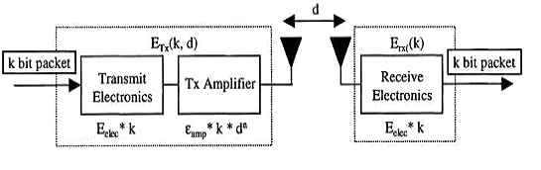

Fig. 3. Radio Energy Dissipation Model

**V CLUSTERING BASED ALGORITHM**

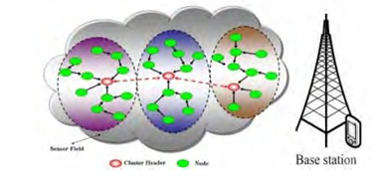

Fig. 4. Clustering Based Routing Protocol Architecture

Many greedy algorithms have been proposed to choose cluster heads in ad hoc networks, and wireless sensor networks. They are based on the criteria of highest degree, lowest- ID, highest-ID, and node-weight, residual energy, probability, and any combination of these. The clustering techniques can also be classified based on cluster size, namely Single hop, and Multi-hop. LEACH (Low-Energy Adaptive Clustering Hierarchy) elects cluster heads based on randomly generated value between 0 and 1. If this randomly generated value is less than threshold value then the node becomes cluster head for the current round. LEACH is the first hierarchical cluster-based routing protocol for wireless sensor network which partitions the nodes into clusters, in each cluster a dedicated node with extra privileges called Cluster Head (CH) is responsible for creating and manipulating a TDMA (Time division multiple access) schedule and sending aggregated data from nodes to the BS where these data is needed using CDMA (Code division multiple access). Remaining nodes are cluster members.

DISTANCE BASED CLUSTER HEAD SELECTION ALGORITHM

It uses two clustering parameter to select CH: one is residual energy, and the other is communication cost. The communication cost is defined as an average minimum reach ability power, which means the minimum power levels required by all nodes within the cluster range to reach the CH. The communication cost held by CHs is used to let a node which belong to several CHs choose the best one.

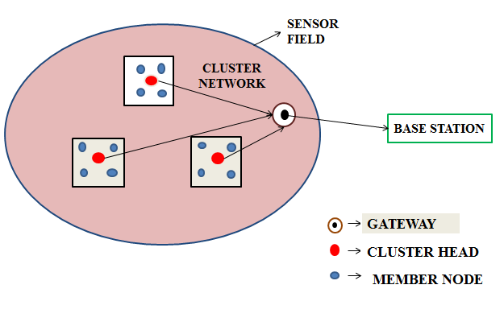

Fig. 5. Cluster Head Model in Wireless Sensor Network

Each node must be mapped to exactly one cluster, and each node belongs to its only CH within one hop. After a clustering process, each node can either elect to become a CH due to a probability or join a cluster according to CH messages. Sensors measure real-world conditions, such as heat or light, and then convert this condition into an analogue or digital representation.

To select a cluster head following steps are followed:

1. Placing sensor node

2. Clustering process

3. Selecting cluster head

4. Remaining node select as member node

5. Sensing information from member node

6. Transferring information to base station.

In WSN after creating the clusters we have to decide the cluster head .Here we propose an algorithm for selecting cluster head based on distance,

Step 1 :

Consider S as source node

S = { S1 , S2 , S3 , …………… Sn }

n = Number of nodes used

Step 2 :

Calculate the distance of node

for i = 1 to n

for j = 1 to n

dij = distance from Si to Sj

Step 3 :

Calculate the sum of all distance ( Di)

for i = 1 to n

for j = 1 to n

Di = Di + dij

Step 4 :

Calculate the distance from BS ( BSi )

for i = 1 to n

BSi = Distance from BS to Si

Step 5 :

Calculate the net distance with BS

for i = 1 to n

NDBSi = BSi + Di

Step 6 :

Select the cluster head based on distance

NDBSi = min ( NDBS1, NDBS2,… NDBSn)

And an corresponding node will be selected as a cluster head.

Step 7 :

Calculating the threshold values for the node ( n)

Davg = $\frac{1}{n}$ $\sum_{i}^{n}{Di}$

If Di < Davg then we use,

T $\left(n\right)=\left\{ \begin{aligned}\frac{p}{1-p* ( r mod \frac{1}{p })}*( 1-\frac{Di}{Davg} ) \\ 0 , otherwise \end{aligned}\right., n € G$

If Di >= Davg then we use,

T( n ) = $\left\{\begin{aligned}\frac{p}{1-p* \left( r mod \frac{1}{p }\right) } , n € G \\ 0 , otherwise\end{aligned}\right.$

After performing all steps in above mentioned sequence, we found that node S(i) has smallest distance in comparison to other nodes. So, we can conclude that if node S(i) is selected as a cluster head, node S(i) will consume less energy in comparison of other node.

LEACH, TEEN, APTEEN and PEGASIS have similar features and their architectures are to some extent similar. The performance measurements of protocols are mentioned in Table 1.

TABLE 1

PERFORMANCE MEASUREMENT OF ROUTING PROTOCOLS

|  |  |  |  |  |  |
| --- | --- | --- | --- | --- | --- |
| Protocols | Mobility | Power management | Network lifetime | Scalability | Resources Awareness |
| LEACH | Fixed  BS | Maximum | Very Good | Good | Yes |
| TEEN | Fixed  BS | Maximum | Very Good | Good | Yes |
| PEGASIS | Fixed  BS | Maximum | Very Good | Good | Yes |
| APTEEN | Fixed  BS | Maximum | Very Good | Good | Yes |
| SPIN | Supported | Limited | Good | Limited | Yes |

**VI SIMULATION RESULTS**

To evaluate the performance of proposed algorithm, we simulate the algorithm and LEACH, QB-LEACH, EECH, DBCH with 150 random nodes in NS2.

In this section, the nodes spread into a 500 x 500 area. All nodes have 2j energy cost of transmitter and other parameters value mentioned in Table 2.

TABLE 2

PARAMETER VALUES IN SIMULATION

|  |  |
| --- | --- |
| PARAMETER | VALUES |
| Simulation Area | 500 x 500 |
| Number of nodes | 150 |
| Channel Type | Wireless channel |
| Energy model | Battery |
| Energy cost of Transmitter  ( Eelec ) | 2J |
| Node Distribution | Random |
| Radio Propagation model | 2 ray model |
| Data packet size |  |

Here we use three metrics to qualify the network. FND (First Node Die) is very important so it is employed for application including on industrial or domestic gas and fire detection, this metric is used because dying one or more node might cause of mistake or danger on the case study.

Other metric parameter is HND (Half Node Die) that demonstrate the number of round that half-number of all nodes die, until this round we still have a view of entire environment. LNA (Last Node Alive) show the last round that there is minimum view.

These parameters are simulated in NS2 to compare the outcomes with other simulated algorithm results (Table 3).

TABLE 3

COMPARISON OF THE RESULTS

|  |  |  |  |
| --- | --- | --- | --- |
| Algorithm | FND | HND | LNA |
| LEACH | 735 | 1082 | 1291 |
| QB-LEACH | 1141 | 1258 | 1311 |
| EECH | 1183 | 1294 | 1433 |
| DBCH | 1212 | 1475 | 1695 |

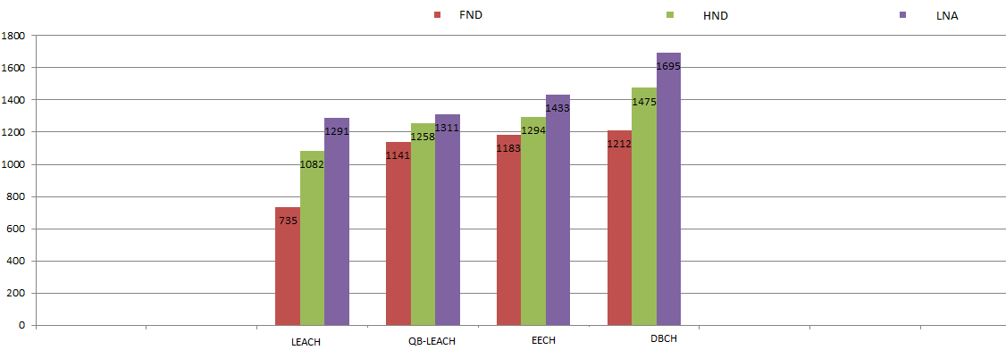

Fig.6 ( Round for FND, HND, LNA )

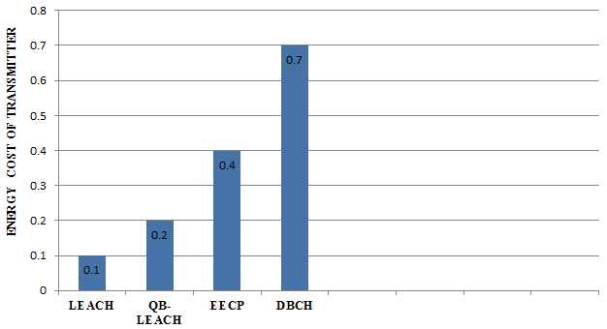

Fig. 7 ( Energy cost of transmitter )

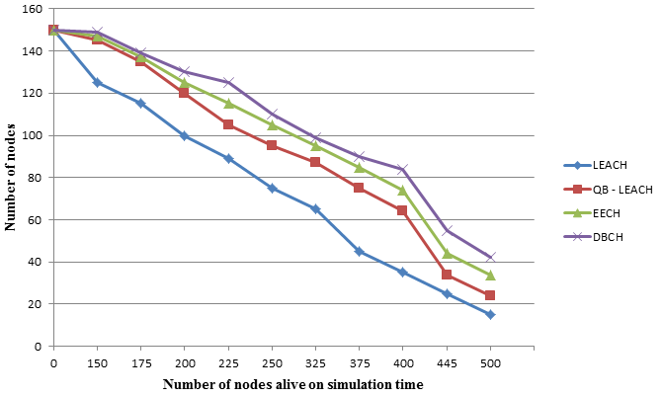

Fig. 8 ( No. of nodes alive )

Simulation result show that the proposal acts better than other algorithm in FND and HND, for LNA also is better than LEACH, QB-LEACH, EECH and DBCH ( Fig. 6).

Figure 8 shows that number of alive nodes are more in DBCH as compared to other protocols.

**VII CONCLUSION**

The routing techniques are classified as proactive, reactive and hybrid, based on their mode of functioning and type of target applications. Further, these are classified as direct communication, flat and clustering protocols, according to the participating style of nodes. Again depending on the network structure, these are categorized as hierarchical, data centric and location based. We have compared various protocols and future work will be focused on saving energy with concept of mobile sinks in various protocols.

**REFERENCES**

1. Manpreet Kaur Aulakh, Analysis of energy efficient clustering scheme in wireless sensor networks, International Journal of Innovative research in Electrical, Electronics, Instrumentation and Control Engineering (IJIREEICE), Vol. 5, no.3, March 2017.
2. Vidhya Ramu and Neha Mariam Joseph, A spectral clustering approach to identifying cuts in Wireless Sensor Networks, International Journal of Emerging Technology in Computer Science & Electronics (IJETCSE), Vol.20, no.3, March 2016.
3. M. Taheri, Energy Efficient Clustering Algorithm for Wireless Sensor Networks using Fuzzy Logic, International Journal of Computer Applications, Vol.89, no.14, March 2014.
4. Jenq-Shiou Leu, Energy Efﬁcient Clustering Scheme for Prolonging the Lifetime of Wireless Sensor Network With Isolated Nodes, IEEE Communications Letters, Vol.19, no.2, February 2015.
5. Surender Kumar, Energy Efficient (EECP) Clustered Protocol for Heterogeneous Wireless Sensor Network, International Journal of Advanced Research in Computer Science and Software Engineering, Vol.3, no.7, July 2013.
6. Hla Yin Min and Win Zaw, Performance Evaluation of Energy Efficient Cluster based routing protocol in Wireless Sensor Networks, International Journal of Computer Science Engineering (IJCSE), Vol.3, no.02, March 2014.
7. Mari Carmen Domingo, A Distributed Clustering Scheme for Underwater Wireless Sensor Networks, International Symposium on Personal, Indoor and Mobile Radio Communications (PIMRC'07), Vol.1, no.7, May 2009.
8. S. Gladwin Moses, Cluster Based Secure Routing for Mobile Sink in Wireless Sensor Networks, International Journal of Recent Trends in Engineering & Research (IJRTER), Vol.4, no. 17, May 2016.
9. Feng Pan and Guangqian Xie, “Cluster-Based Routing for the Mobile Sink in Wireless Sensor Networks With Obstacles”, IEEE ACCESS, Volume 4, May 2016.
10. Ossama Younis and Sonia Fahmy, HEED: “A Hybrid, Energy-Efficient, Distributed Clustering Approach for Ad-hoc Sensor Networks”, IEEE Transaction, 2004.
11. B.Baranidharan and B.Shanthi, A Survey on Energy Efficient Protocols for Wireless Sensor Networks, In Proceedings of the International Journal of Computer Applications (0975 – 8887) Volume 11– No.10, December 2010.